VR251 Aesthetics
Art Apologist Write-up
Pan Chongdan
516370910121
Traditional China Medicine
- Introduction
Traditional China Medicine is also known as ‘TCM’ in short. Compared to western medicine, the origin of TCM was Chinese philosophy. The philosophy considers human body as a part of nature and cosmos. Everything in the world is composed of constantly changing abstract elements, including chi, yin-yang, and five elements, while western medicine is developed from chemical science and biology. In addition, TCM is a qualitative science while western medicine is a quantitive science. TCM doesn’t require a large-scale experimental data from medical facility for diagnosis. It depends more on observation of symptom and pulse.
- Neglection of TCM’s Art
So what’s the reason for negligence of TCM’s art?

Figure1. Hospital Distribution in China
The above graph shows the hospital distribution in China. It shows that only about ten percent of China hospitals are about TCM. Even in the origin of TCM, which is China, there are far more western medicine hospitals. Therefore, we have more chance to encounter western medicine, and our conventional perception to medicine is majorly formed by western medicine and science. Even though for people who know about TCM, they hardly have a deep and systematic understanding, because the original work of TCM is difficult to understand
- TCM’s art in literature
But why is TCM an art? We can find it in its literature first. Huangdi Neijing is considered as the ancestor of TCM. Different from common science book, Huangdi Neijing’s words have neat and balanced form, melodious and harmonious rhythm, making it more like a literary and artistic work.
In addition, there many legendary doctors with mythical stories in the TCM’s history, for example, Hua Tuo and Bian Que, are commonly believed as miracle-working doctor, who can treated any disease with mysterious prescription. No matter whether these stories are true, they can arouse our curiosity as well as exclamation. Artistic expression is also widely used terminology. For example, in TCM, the word 上火, which is ‘on fire’ in English, can be used to describe symptoms like ulcer and inflammation. Although our body can’t actually burn inside, we can use the word “on fire” to express our feeling vividly when we have some pain in our body.
- TCM’s art in philosophy
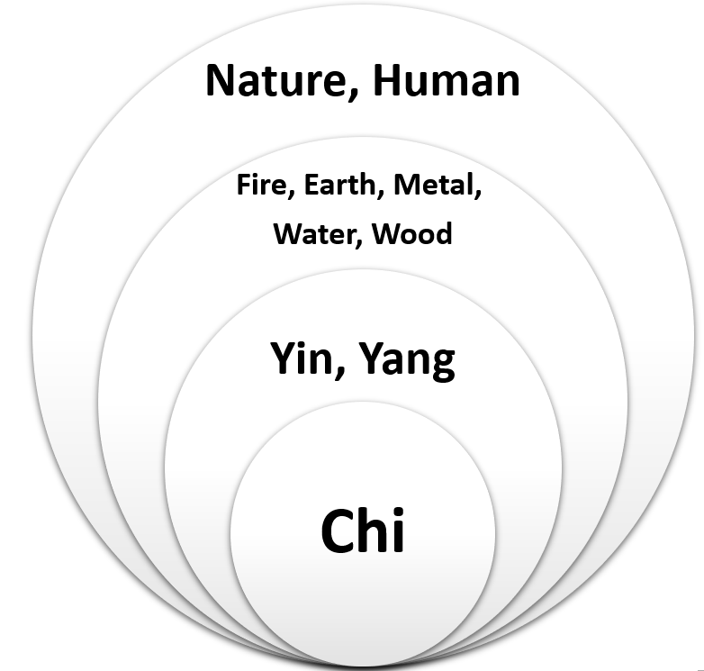
Figure 2. TCM philosophy
In TCM’s philosophy, it argues that, essentially there is no difference between human and anything else. Everything is generated from chi, and they should be treated equally. TCM’s philosophy is complete and designed to unify the world and human together and treat them in one principle. Therefore, TCM is a qualitive science. It depends little on a large scale of data or technology and tend to use natural to treat against disease, rather than synthetic polymers. Some chronic diseases are extremely intractable for western medicine, but it can be readily solved by TCM. There goes a saying “Great artwork needs no work”, perhaps TCM can be described as well “Great medicine needs no medicine”.
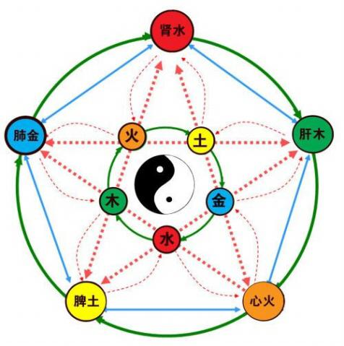
Figure 3. Yin-Yang and Five Elements
On the other hand, the theory states that everything is associated with interactions of five elements. The five elements are changing constantly and connected together, hence treatments in TCM philosophy also vary with each individual.
For TCM doctors, they concentrate on using different ways to achieve balance and harmony of the five elements in human body, rather than treat specific disease. Therefore, TCM is plural in its philosophy, and the pursue for harmonious makes it more like an aesthetic experience. Besides, because of plurality, treatment in TCM requires imagination as well as experience. With imagination and creation, TCM treatment is more like an art rather than a therapy.
- Relation to our Reading
We can regard TCM as art through arguments from our readings. According to Neo Representation theory, TCM is an artwork, because it has an object, which is medicine, and it uses Chinese Philosophy express its opinion to medicine. In Hepburn’s article, he claims that aesthetics is at the point between plurality and unity, which are both contained in TCM’s philosophy. TCM is like a combination of natural beauty and normal artworks. For normal people, its complexity and mystique build a frame, but for doctors, TCM has beauty like nature, due to its uncertainty and requirement for imagination in practice. After all, TCM is about nature but only experts can have a fully understanding to it.

- Reference
1. Raphals, Lisa. Chinese philosophy and Chinese medicine. The Stanford Encyclopedia of Philosophy. 2017 https://plato.stanford.edu/archives/fall2017/entries/chinese-phil-medicine
2. Noël Carroll: Philosophy of art, A contemporary introduction, Routledge 1999[J]. British journal of aesthetics, 2002, 42(2):211-214.
3. Hepburn, R.W. Contemporary aesthetics and the neglect of natural beauty. British Analytical Philosophy. 1996

